769 Deactivator Instructions

1. Overview
RF Decoder is the accessory of the 8.2MHz EAS RF System.Consists of the 8V DC power adapter and the deactivator panel.When connect the power,the deactivator will show the green light,and it’s standby mode is on.when decoding the label,it will show the red light and buzzer sounds at the same time.When decoding label,it’s better to take the items be close to the center of the decoder panel and try several times back and forth until the buzzer does not sound. The decoder match the 8.2MHz RF detection system to use, generally installed on the cash desk, to decoding the protection commodity.

2.Power Description
a:Power supply
Input power:18V DC 1A
Supply fuses:1A,250V
Decoding height:max 15cm(soft label)
Maximum current:150mA(Decoding)
Quiescent current:less than 110mA

b:Installation Preparation work
(1) determine the installation location, hole size 205mm * 215cm
(2), connect the power adapter and decoder, to observe whether the adapter is adapt with the regional power grid.

c. Decoder Machine icon
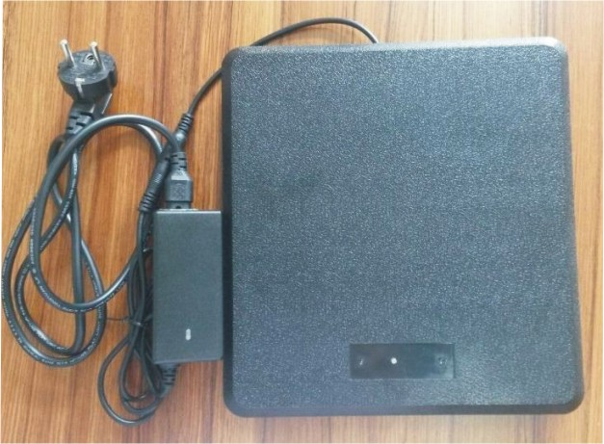

d.Deactivator Panel Icon

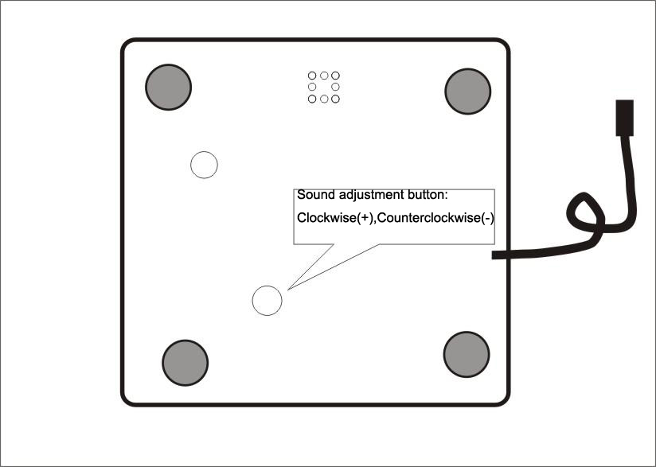

e.Power Connecting
The waterproof power plug is plugged in and seated, as shown below:
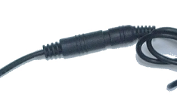

3, The Deactivator Uses
The decoder has a hard tag recognition. When decode a soft label that entering into the decoder area, the buzzer Didi tick (three short beeps), decoding success. If hard tags into the decoding region, the buzzer beep is issued (long tone), alarm reminder.

4, The Sound Adjustment Function
Adjust the deactivator alarm sound,as the pic , clockwise to increase the sound, counter-clockwise to decrease the sound.

5. Notes
Do not put liquid or easily dissolved solids directly on the decoder surface, it should be wrapped to prevent liquid into the decoder and burn circuit boards.

