RF MONO SYSTEM Instruction manuals

1.Performance and Characteristics of Introduction.

2.Antenna,Power Connection Diagram circuit board layout

3.Installation steps.

4.Function Introduction&Using.

5.Simple Troubleshooting.
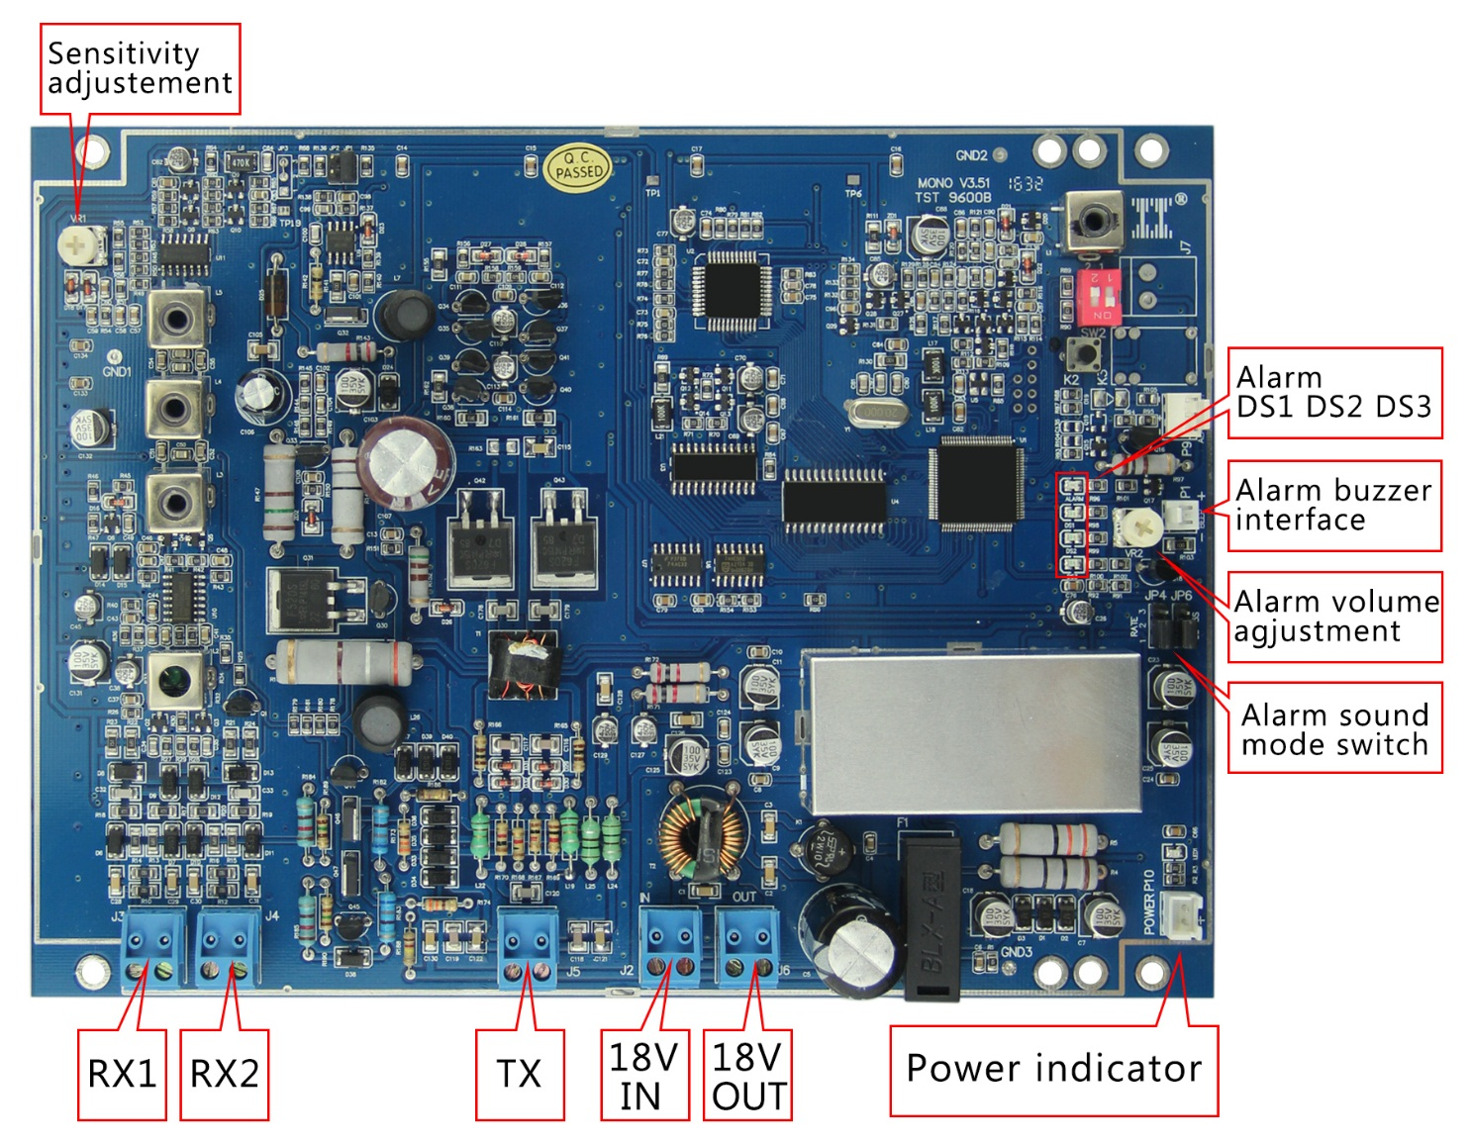

1.Performance and Characteristics of Introduction.
1.Several Radio Frequency antennas can work together at the same time without Mutual Interference,Synchronization not required between antennas and Easy to installation,Especially suitable for independent double channel installation and wide distance door installation.
2.The standard detection distance and maximum detection distance（Below:Drawing 1）
Tag type | Detection distance
40×40mm soft label | Standard 0.8m、maximum 1m（Each side）
Big tag | Standard 1m 、maximum 1.2m（Each side）
(Drawing 1)
Use limitation:
Installation of single support radio frequency antenna(MONO SYSTEM),Please pay attention to the surround environment wether using 8.2MHZ frequency antenna system, namely transmitting antenna - receiving antenna collaborative working 8.2 MHz continuous wave RF test system,When single support radio frequency antenna distance RF 8.2MHZ continuous wave more than 20 meters,，then it is security installation distance.Depending on the installation position and direction is different ,The critical installation distance is 8 meters.But in order to anti-interference,we need to lower the sensitivity of equipment appropriately，normally the detection distance will be shorten 20%~30%（maximum detection distance around 1.1）,exactly detection distance depending on real environment.

2.Antenna,Power Connection Diagram circuit board layout 3.Installation steps
Please power-on test the Electric field environment of installment position before fixed the antenna.
（1）Equipment connect well power cord ，putting in the install position，at this time on mono board, DS1-DS3 three green lights flashing and then put out，Alarm not bright is normal
（2）Observation receiver board four green interference light DS1, DS2, DS3, ALARM
DS1,DS2,DS3,ALARM all are not bright :indicated very good environment，suitable for installation;
DS1 flashing,DS2,DS3,ALARM all are not bright:Incinerated good environment，through debugging sensitivity，can be installed;
DS1,DS2 bright，DS3 not bright or all four lights bright，indicated badly environment，need to adjust before installation.

The adjustment methods as following:
A,Adjust installation position，avoiding the interference source.
B,Eliminate interference source
Remark:interference source usually as below:
①Equipment too close to the wall of cable;
②There have coiling coil near the equipment，like lantern,Christmas tree ect;
③Equipment too close to power distribution cabinet, high voltage electrical equipment etc.
4.Function Introduction&Using

A.Sensitivity debug
Debug VR1 potentiometer on board（top left corner of board) to decrease or increase sensitivity.clockwise debugging:increase sensitivity,anti-clockwise debugging:decrease sensitivity.Debug principles: try best to decrease the sensitivity on condition of equipment work properly.when several antennas install at the same time,please individual power-on and debugging well of them,then power-on all equipments,at this time,DS1,DS2,DS3 will keep flashing,indicated normal.

B.Anti-interference debug
Under some special environment,such as near wall or power line,or surround of equipment there have some RF frequency facility easy to cause false alarm.dial the fourth of SW2 to K1，improve equipment anti-interference ability.（Remark: Function,and equipment sensitivity will be declined)

C.Alarm sound strength debug
Debug VR2 potentiometer at up right corner of board to control alarm sound strength，clockwise debugging:increase ,anti-clockwise debugging:decrease .
5.Simple Troubleshooting
1.Under normal situation,single support radio frequency antenna can usually long-term stable work. it is rare since components failure resulted of the system fault .most failure due to error use,power supply socket link problem,ac voltage fluctuation,connecting cable loose connection,surrounding electronic facility and some other radio interference,cable,coil,metal frame equipment causing interference.Careful analysis to find the cause of the problem.please don't change system Settings and parameters at will before find out the cause of the problem，Because each index under good situation before equipment leave factory，without relevant instruments and debugging them at will,it will be more difficult for you to judgment the fault and eliminate them.
2.The system doesn't work properly,such as the detection sensitivity to reduce, not alarm or frequent false alarm, etc, General as following steps to check:
(1)Check the power supply
a.Find out system doesn't work properly, you should check whether the system power is normal, whether power indicator light is bright,whether Printed circuit board fuse (F1) is in good ,whether Input power supply voltage is correct (18 vac)；whether the power supply connection is disconnected or short circuit,whether External power adapter work properly,whether the power socket linked well,whether the input voltage fluctuation is big,ect.
b.Only ruled out the power failure,then you can check other fault of system.
3.System detection sensitivity reduced
It is rare since components failure resulted of the system detection sensitivity reduced at normal situation.Most similar failure are for interference and inhibition between system,metal objects and electrical equipment nearby test antenna ,at possible situation,electrical equipment should to be far away from detection antenna .
4.System not alarm
If alarm light doesn't shine and doesn't beep when detection tags,firstly you should check whether alarm light and buzzer connected well and whether alarm light and buzzer damaged .if not ,please check the indicator light "ALARM":"bright" show that the system has alarm,but no alarm output,at this time you should considered part of the circuit fault(component failure or damage).
Attention:when environmental interference is very serious(noise level indicator light full bright),system can't work properly.
5.System false alarm
Radio frequency antenna:adventitious false alarm phenomenon is allowed by some radio waves or electrical switch spark and similar broadband interference source of interference，not belong system fault range.But frequent false alarm even continuous self singing is an serious fault,then we should find out the strong interference source and eliminate fault,in addition,we should have to check system itself and eliminate them.we also can dial the fourth of SW2 to K1 to improve the anti-interference ability,but sensitivity reduced.
Usually another common reason cause system false alarm is putting label on the power line advice:checking is there any tag near the adapter's power supply cable.

Inspection diagram:
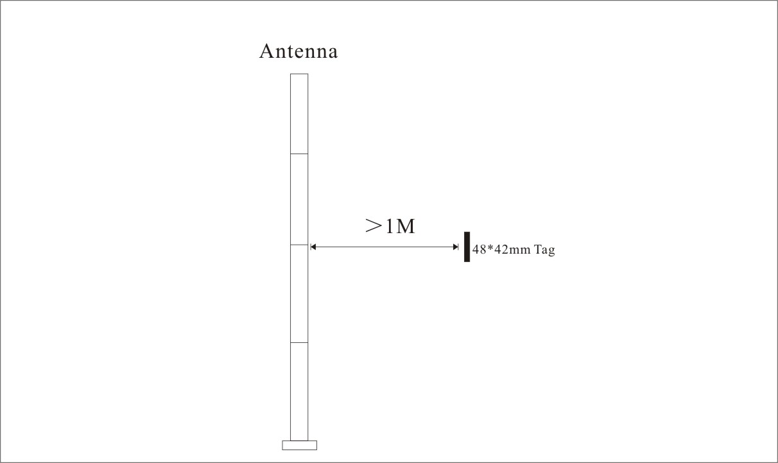
1．Tag parallel to antenna,alarm distance exceed 1 meter（small square tag）
2．Alarm indicator bright, alarm sound loud (standard)

Connection diagram
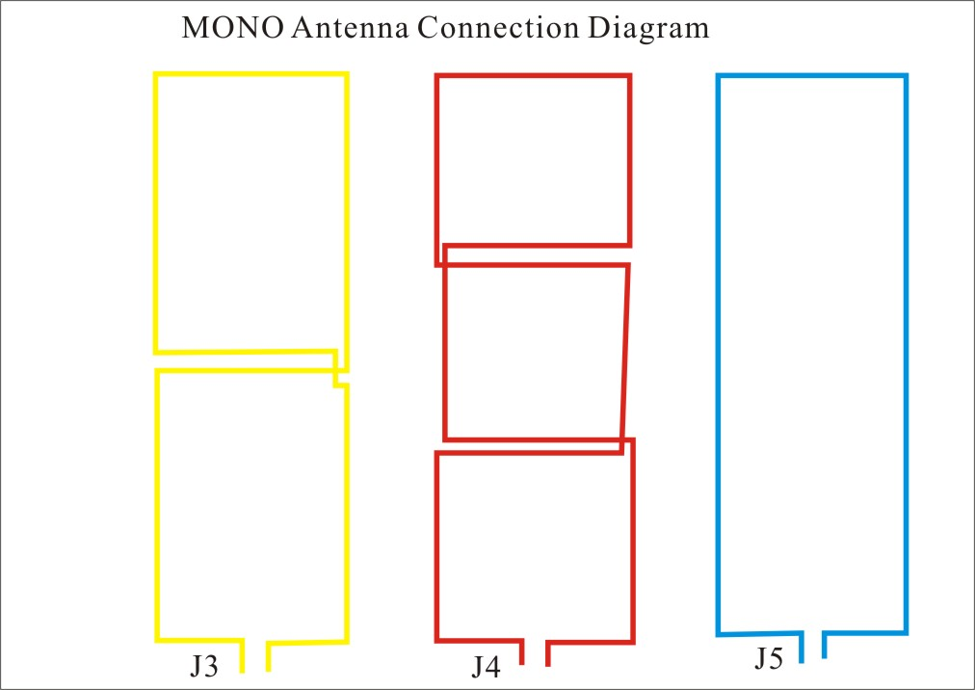
(single 8 sharp) (double 8 sharp) (n sharp)

